11/28/2020

RAIHAN MD RAKIBUL ISLAM

2020380029

**HOME WORK**

**9.1**

**9.1**

4. Determine whether the relation R on the set of all people is reflexive, symmetric, antisymmetric, and/or transitive, where (a, b) ∈ R if and only if

a) a is taller than b.

**A:** Antisymmetric and transitive

b) a and b were born on the same day.

**A:** Reflexive, symmetric and transitive.

c) a has the same first name as b.

**A:** Reflexive, symmetric and transitive.

d) a and b have a common grandparent.

**A:** Reflexive and symmetric

6. Determine whether the relation R on the set of all real numbers is reflexive, symmetric, antisymmetric, and/or transitive, where (x, y) ∈ R if and only if

a) x + y = 0.

**A:** The only existing example of an ordered pair (x,y) where y = x and x + y = 0 is (0,0). Therefore, the set R does not represent all values of (x,x) where x is any real number, so the relation isn't reflexive. The relation is symmetric (and by the following logic, antisymmetric), because if x + y = 0, making (x,y) an element of R, and y + x = 0, then (y,x ) must also be an element of R. The relation is not transitive, since, for example (-3,3) and (3,-3) are elements of the set R, but (-3,-3) is not.

c) x − y is a rational number.

**A:** The relation is reflexive because all number minus themselves equals 0, meaning all ordered pairs of (x,x) are represented. The relation is symmetric, because if x-y = a rational number then y - x = a rational number. This also means that that the relation is not antisymmetric. The relation is transitive. If x-y = a rational number, and y - z = a rational number, the x - z must also equal a rational number.

e) xy ≥ 0.

**A:** This relation is reflexive because any two equal numbers will result in either a zero or a positive number. This means that all values of (x, x) are included in R. The relation is also symmetric, because if xy is greater than or equal to 0, then yx is also greater than or equal to 0. Therefore, for every (x, y) ordered pair, there is a (y, x) pair in R. By this logic, the relation in not antisymmetric. This relation is not transitive. Should y equal 0 and x and z have different signs, then (x, y) and (y, z) will be in R, but (x, z) will not be. Look at this example: The ordered pair (2,0) is an element of R. So, it (0, -3). (2, -3) is not however, because (2) (-3) < 0

26. Let R be the relation R = {(a, b) a<b} on the set of integers. Find

a) R-1.

**A:**

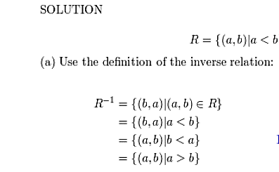

b) ̅R

**A:**

